

**PI Tag Creator Module Developer Manual**

**for the**

**I-Field Tags Synchronization System**

**at**

**EXPEC Computer Center (ECC)**

Saudi Aramco, Saudi Arabia

|  |
| --- |
|  |

**Document Type: Developer Manual**

**Document Name: ECC PI Tag Creator Developer Manual**

**Version: 1**

**Version Date: 11-May-2018**

**Crucial Solutions & Services (CSS)**

**Address**: P.O. Box 10381 | Jubail Industrial City 31961 | Kingdom of Saudi Arabia   
**Tel**: +966 (013) 349 3391 | **Fax**: +966 (013) 349 3392

**Email**: sales@css.net.sa | **Website**: [www.css.net.sa](http://www.css.net.sa)

Copyright © 2018 Crucial Solutions and Services (CSS)

The information contained herein is the sole property of Crucial Solutions & Services (CSS)**.** This document is reserved for viewing by EXPEC Computer Center (ECC), Saudi Aramco (Aramco) and consented recipients. No part of this document, may be reproduced, transmitted or modified (in any form or by any means) outside of the intended recipients without the express prior written consent of Crucial Solutions & Services (CSS).

Windows, SQL Server, SharePoint, Office, and Excel are registered trademarks of Microsoft Corporation.

ProcessBook, DataLink, WebParts, Coresight, AF, HA, and PI are registered trademarks of OSIsoft Inc.

All other trademarks are the property of their respective owners.

Revision History

|  |  |  |  |
| --- | --- | --- | --- |
| Rev | Date | Updated by | Revision Comments |
| 1 | 11-May-2018 | Houssam Al Moughrabi | First Issue |
|  |  |  |  |
|  |  |  |  |
|  |  |  |  |
|  |  |  |  |

Table of Contents

SECTION 1: Summary 4

SECTION 2: Architecture 5

2.1 Diagram 5

2.2 ECCPITagCreator_Service - Windows Service 6

2.3 ECC_DataLayer - Data Layer 7

2.3.1 Repositories 7

2.3.2 Stores 7

2.3.3 Helpers 8

2.3.4 DataModels 8

2.4 ECC_ServicesLayer – Service Layer 9

2.4.1 Services 9

2.4.2 Helpers 10

SECTION 3: Workflow 11

3.1 Diagram 11

3.2 Description 12

3.2.1 Get the non-created tags from oracle database 12

3.2.2 Check existence of instrument tag in ECC PI Server 12

SECTION 4: Database Dependencies 13

SECTION 5: Service App.Config 14

SECTION 6: Installer 15

# Summary

This document describes the development manual of the PI Tag Creator part of the I-Field Tags Synchronization System Project at ECC, Saudi Aramco

This Manual considers a Visual Studio 2017 installed as a pre-requisite.

# Architecture

This section will visualize and describe how the code is structured for this service.

Each module represented is a standalone .NET project which are connected together via reference.

The main objective of this architecture is to provide a scalable and flexible solution implemented in multiple projects each with a specific role and concern.

## Diagram

**Windows Service**

**ECCPITagCreator_Service**

**ECC_DataLayer**

**.NET Class Library**

Oracle DB

**ECC_Services_Layer**

**.NET Class Library**

PI AF SDK

PI AF/

PI Data Archive

## ECCPITagCreator_Service - Windows Service

This is a windows service which is the main output project that will be installed on the server.

The main role of this module is to wrap all the logic implemented inside a windows service and handle the execution of the process.

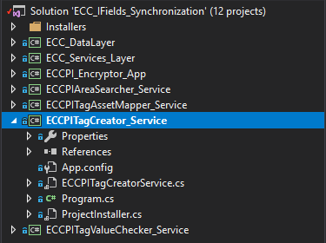

## ECC_DataLayer - Data Layer

This is a .NET class library responsible for communicating with database (mainly Oracle).

The data layer contains all the methods that are used by the service to Get/Update/Write data in database, also it contains the data models that represents the tables in the database.

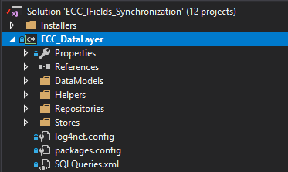

Here is how the data layer is composed:

### Repositories

This is the repository which contain the classes and methods that Open/Close connection with the database, Execute a query (sync or async) using dapper ORM and Read a query from the ***SQLQueries.xml*** file.

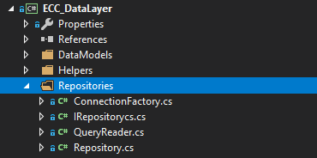

### Stores

This namespace contains the implementation of the queries used, each class is for a specific windows service and contains all the methods that being used for executing the queries.

All stores inherit the ***DataStore.cs*** which implements some generic methods related to all inherited stores.

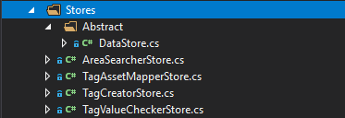

### Helpers

This namespace implements the general functionalities that could be used by any module or class in the project such like Encryption/Decryption of text or Logging.



### DataModels

It’s a representation of the tables used in the queries (specifically the SELECT queries) to manipulate from within the code.

The queries results are mapped into these models using Dapper ORM (.NET SDK).

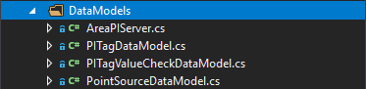

## ECC_ServicesLayer – Service Layer

It contains all the business logic behind the service and communicate with PI Data Archive/ AF via SDK and also communicates with the ECC_DataLayer when needed.

All the services required for the I-Field Tags Synchronization project are implemented inside this .NET class library.

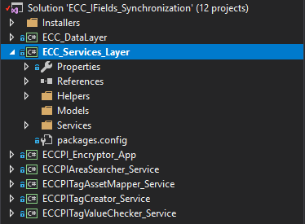

Here is how the services layer is composed:

### Services

This namespace contains the implementation of the business logic of all services, each service is represented with a class where it contains all the workflow.

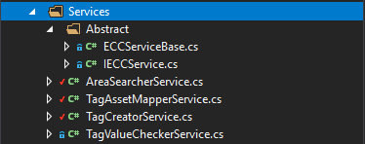

### Helpers

Contains the generic functionalities that are being used by all the services such like Objects Mapping, Communication with PI or AF via PI AF SDK and Service Job scheduling.

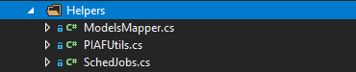

# Workflow

**ECCPITagCreator** is responsible for creating tags into ECC PI Server that has been flagged as ready to be inserted.

## Diagram

Below a diagram representing the workflow.

Get the non-created tags from oracle database

Check existence of instrument tag in ECC PI Server

Schedule next execution date/time

If exist

Else

Check if tag is flagged to be renamed

Yes

No

Rename the tag in ECC PI Server

Update the existing tag name in database

Create tags in ECC PI server

Update tags records in database

Store the number of tags created

## Description

### Get the non-created tags from oracle database

Query the tags from the ECCPI_AF_WELL_FOUND_TAGS that aren’t created in ECC PI server.

### Check existence of instrument tag in ECC PI Server

For each tag check if the tag name filled in AREA_PI_TAG_NAME already exist in ECC PI server as an instrument tag to avoid conflicted tags creation.

* If Exist
  + **Check if tag is flagged to be renamed**: ECCPI_TAG_REN_RQST_FLG=’Y’?
    - Yes?
      * **Rename the tag in ECC PI Server**: Override the tag name in ECC PI server with the ECCPI_TAG_NAME value
  + **Update the existing tag name in database**: Store the current tag name in ECCPI_EXST_TAG_NAME column and set ECCPI_TAG_CRE_FLG to ‘Y’
* Does not exist
  + **Create tags in ECC PI server**: using PI AF SDK create the missing tags in ECC PI SERVER
  + **Update tags records in database**:
    - For success tags: Set ECCPI_TAG_CRE_FLG to ‘Y’ with remark
    - For error tags: Put remark and update ECCPI_TAG_CRE_FLG if needed.
  + **Store the number of tags created**: Update number of tags created for each I-Field in ECCPI_POINT_SOURCES table

# Database Dependencies

The table contains the main columns/flags that are being updated after the execution of the service.

|  |  |  |  |
| --- | --- | --- | --- |
| Table | Column Name | Type | Usage |
| ECCPI_AF_WELL_FOUND_TAGS | ECCPI_TAG_CRE_FLG | Char | Used to identify if the tag is created in ECC PI server. When ‘Y’ means created. |
| ECCPI_AF_WELL_FOUND_TAGS | ECCPI_TAG_CRE_REM | Char | Used to write the responses returned from the ECC PI Server when creating the tag, both failed and successful responses are logged here to help identifying the problem. |
| ECCPI_POINT_SOURCES | NUM_OF_TAGS | Number | This number is updated (incremented) after each I-Field tags creation in ECC PI Server to keep track on the number of the tags created. |

# Service App.Config

This file is located under the **ECCPITagCreator_Service** windows service and it contains the below keys.

|  |  |
| --- | --- |
| Key Name | Description |
| ECC_PI_ServerName | ECC PI Data Archive server name or collective |
| ECC_AF_ServerName | ECC AF server name |
| ECC_DB_DataSource | Oracle data source name |
| ECC_DB_UserId | Oracle user Id |
| ECC_DB_Password | Encrypted oracle user password generated from Encryption tool |
| RUN_FREQUENCY | The running frequency of the service.  Example: Daily, Weekly, Monthly or Yearly |
| RUN_HOUR | Time of scheduled job in Hours |
| RUN_MINUTE | Time of scheduled job in Minutes |

# Installer

This section describes where the installers are located inside the source code and how to generate an installation file for windows service.

The installer is a .NET Setup Project configured to build the windows service output and pack it into an installer file (.msi and .exe file).

Setup project is located under **Installers/** directory, there is located the setup project of all services each in a separate project as shown in the below image.

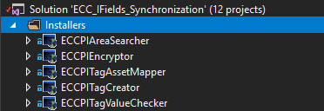

Once the developer has changed in the service code regardless in which project the changes has been made, a new installer should be provided to apply those changes.

In order to do that follow the below steps:

1. Locate the **ECCPITagCreator_Service** Setup Project under **Installers/** directory
2. **Right click** and then click on “**Rebuild**”
3. Wait until the build is done then **Right click** on the project and click on “**Open folder in file explorer**”
4. Locate the installer under **Debug/** directory and double click on one of the installers created (.msi or .exe) to start the installation process.